Pursuant to Wisconsin Statutes 19.84, Notice is hereby given to the public that a meeting of the Recycling Committee of the City of Amery will be held on January 13th, 2026 @ 1:30 pm at 104 Maple St. W, Amery, WI.

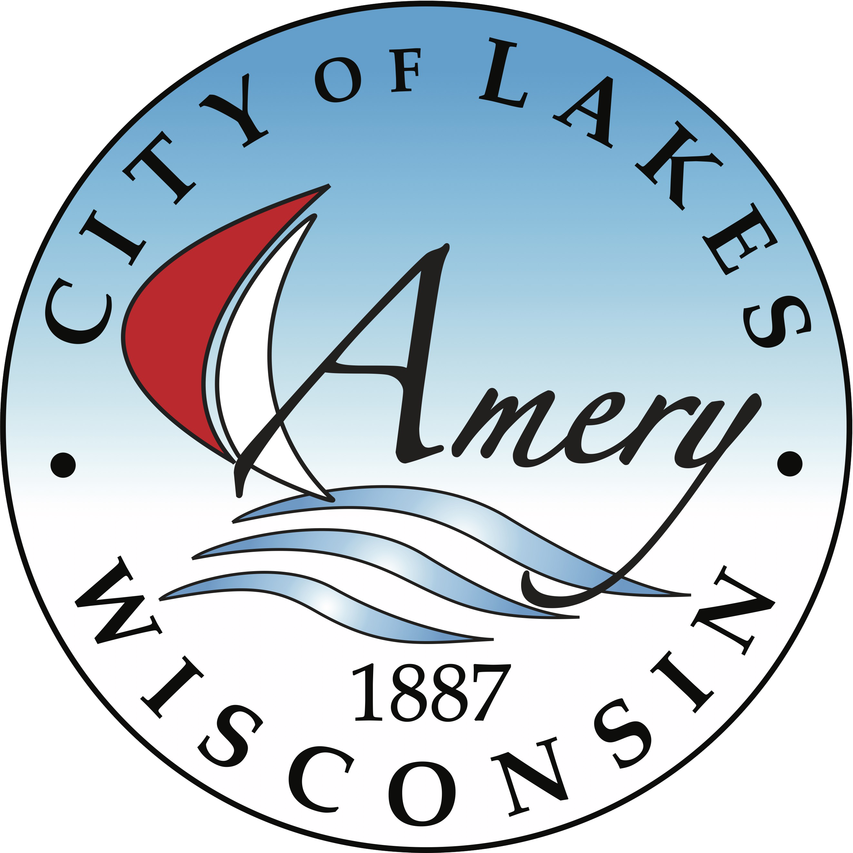

Call to Order

Order of Items | AGENDA ITEMS
1 | Approval of Minutes from 12-02-2025
2 | Polk County Recycling Update
3 | January Topic – Tree and cardboard recycling
4 | February Topic – Mattress, tire and battery recycling
5 | March Topic- Medication Disposal
6 | Adjournment
Adoption of Agenda

Respectfully Submitted.

Lisa Gunderson
Deputy Clerk-Treasurer
**Posted November 25^{th,} 2025, on the city website (www.amerywi.gov); and at Amery City Hall, Amery Public Library, and the Amery Police Department.
Next meeting is scheduled for January 6th, 2025 at 9:30 AM

